Student name: Thinh Le

# Graph 1: Top 5 Crimes occur the most at Night (6 PM to 12 AM) in Los Angeles

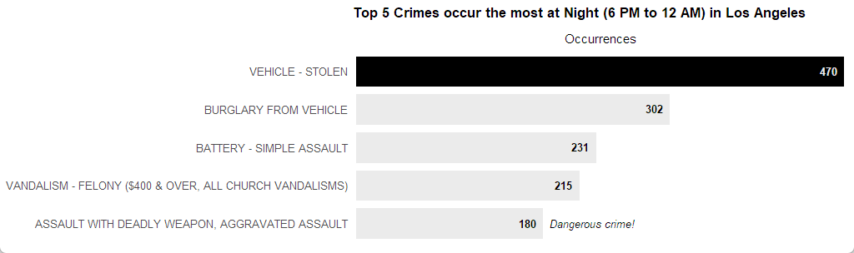

Figure 1: Top 5 Crimes occur the most at Night (6 PM to 12 AM) in Los Angeles

**Short description**: This horizontal bar chart shows the occurrences of the top 5 crimes that usually happen from evening (6 PM) to midnight (12 AM) in Los Angeles from 2020 to 2024. We can observe that 'Vehicle - Stolen' is at the top of the list with 470 cases. Fortunately,  the most dangerous crime, 'Assault with a deadly weapon, aggravated assault',  has the fewest occurrences among the five. So, be careful when going out at night!

Modifications:

* Used reorder() to sort the data in descending order by the number of crimes.
* Used geom_bar() to display the data as bars, sorted by crimes' occurrence with a condition to fill the longest bar in black, while other bars are gray.
* Used geom_text() to add the crime occurrences inside each bar with some padding. The text is bold with a font size of 3.5. There is a condition to display the color differently if the bar is the longest one.
* Used scale_fill_identity() and scale_color_identity() to directly apply custom fill and color names.
* Used scale_x_continuous() to add some padding between the bars and the y-axis, also display the title of the x-axis on the top.
* Used labs() to add a title to the chart and label the x-axis.
* Used annotate() to add a label indicating that 'Assault with a deadly weapon, aggravated assault' is the dangerous crime.
* Used theme_classic() to apply the classic theme.
* Used theme() to adjust the text size, hide the lines and tick marks on both axes. Besides, increase the text size of the chart title and modify the margin of it.

# Graph 2: Crime Rate by Area in Los Angeles

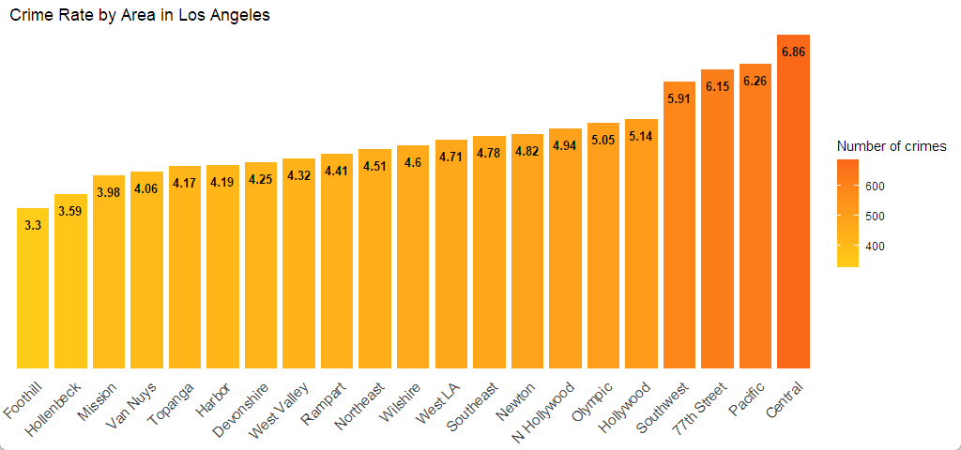

Figure 2: Crime Rate by Area in Los Angeles

**Short description**: This horizontal bar chart shows the number of crimes and crime rates by area in Los Angeles. Central is a dangerous area having the highest crime rate at about 6.86%. Besides, the colors range from light to dark orange, where darker shades mean higher crime rates, and lighter shades mean lower crime rates.

**Modifications**:

* Used reorder() to sort the data in ascending order by the number of crimes by area.
* Used geom_bar() to display the data as bars.
* Used geom_text() to show the crime rate (rounded to two decimals) inside each bar. The texts are set to bold with a font size of 3 and black color.
* Used scale_y_continuous() to adjust the padding between the x-axis and the bars.
* Used scale_fill_gradient() to fill the columns, with higher occurrences being represented by orange, and lower occurrences being represented by yellow.
* Used labs() to add a title to the chart and rename the lengend.
* Used theme_classic() to apply the classic theme.
* Used theme() to adjust the text size on the x axis and rotate it 45 deg, hide the lines and tick marks on both axes.

# Graph 3: Victims' Sex by Age and Time of Crime Occurrence on the Street in Los Angeles.

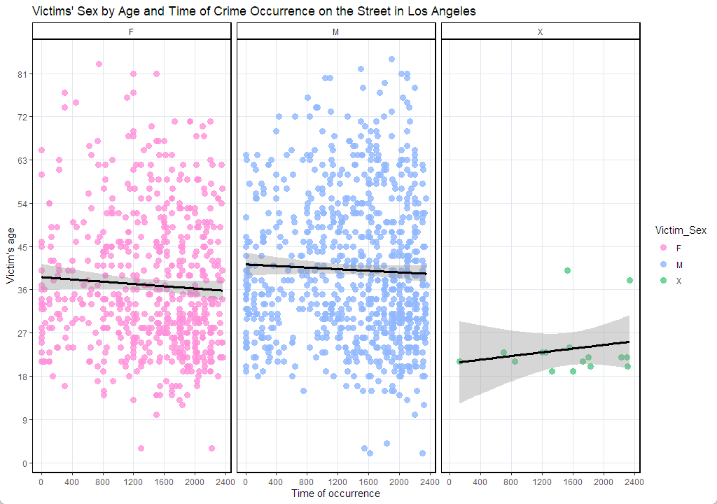

Figure 3: Victims' Sex by Age and Time of Crime Occurrence on the Street in Los Angeles

**Short description**: The chart shows the relationship between the victims' ages and the times when crimes happened on the street, the most common location in Los Angeles. For both genders, 'F' and 'M,' the victims tend to be younger as it gets later in the day. In contrast, for gender 'X,' the victims are older as the time progresses.

**Modifications**:

* Used geom_point() to display points and set the size of the points to 3 with alpha 0.8.
* Used geom_smooth() to show the linear regression line, set the color of the line to black, and set the line width to 1.25.
* Used scale_x_continuous() and scale_y_continuous() to adjust the scale range and interval on the x-axis and y-axis, respectively.
* Used scale_colour_manual() to apply a unique color to each victim's sex.
* Used facet_grid() to view different scatterplots based on victims' sex.
* Used labs() to add a title to the chart and label the axes.
* Used theme_classic() to apply the classic theme.
* Used theme() to change the grid color and add a border to the chart panel.